Name: Océane SOULIER

Name of your Level 1: Morjane SAIDANI

Paper title: Prescriptive Business Process Monitoring for Recommending Next Best Actions

Source: Google scholars

Keywords specific to the paper: business process monitoring, deep learning, prescriptive business process monitoring, predictive business process monitoring, business process management

Summary of the main contributions (use text paragraphs, tables and if necessary, figures):

The document goes further than predictive business process monitoring (PBPM) that predicts future behavior. Instead, it presents a new prescriptive business process monitoring (PrBPM) technique that is able to recognize the next best actions and not only the next most likely. It takes into account key performance indicators (KPIs), which are time, cost and quality.

PBPM techniques use DNNs that learn from event logs data. The issue with that is the flaw in this method: to include KPI is a very difficult task, unless learning KPI is the only target considered. It is not, because the target of PBPM is next activity predictions and it is what the whole process is about. The problem has been partially tackled with PrBPM approaches that are able to prevent undesired activities thanks to alarms or recommended actions. But still, it does not recommend the next best action.

The new technique is evaluated regarding its optimisation of KPI and its distance from ground truth process. It uses two real-life event logs. The business process is also optimized with a control-flow knowledge that avoids issues due to the KPI (to optimize KPI may also mean not conforming to the process control-flow).

It has two components: offline and online. In the offline component, it learns a DNN for predicting new activities and values of a KPI. In the online component, the next best actions are recommended based on the next activity and KPI values.

The technique uses two models:

1. Model m_pp: This model predicts the next activities in a process using a deep neural network (DNN) architecture.

2. Model m_cs: This model is a nearest-neighbour-based machine learning algorithm that predicts key performance indicator (KPI) values based on the suffixes of process instances.

KPI are either scaled numerically or categorically. m_pp is composed of several branches. On each, one layer realizes the next activity predictions, and another layer creates KPI value predictions.

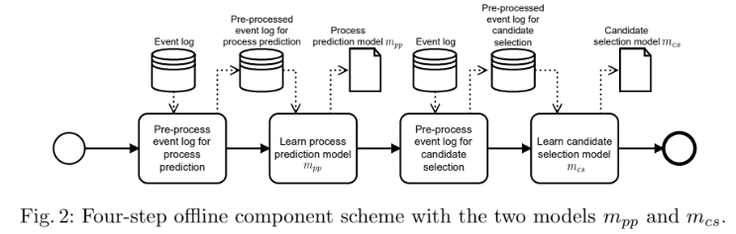

The offline component has to generate the best action and, if unable, at least the most likely activity. It selects the best candidate depending on the KPI. If the best action is the end of the process instance, the procedure ends. Otherwise, it will continue.

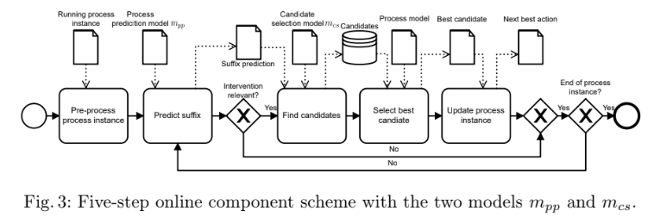

The procedure evaluates both the optimisation of the KPI “time” and the distance from the ground truth process (meaning the distance between two consequences through the minimum number of operations). When it comes to time optimization, resultats are good (better than initially) but have to be nuanced. When it comes to the distance from ground truth process, it has better results. They assume that the results may have been distorted by a few sequences that they don’t know for now.

Their technique is lacunar because:

* they did not optimize the model m_pp
* they have a too flexible definition of a process’ control-flow and may consider using a more procedural process model
* they did not consider dependencies of processes (direct and indirect rebound effect can alter the technique)

To put it in a nutshell, the authors emphasize the need for further works that may have better results, notably considering more advanced DNN architectures (to have better recommendations of next activity / best activity). Their work was only optimizing one KPI at a time, so they consider working on next best actions taking more KPI into account.

AI model used (e.g. Neural network, etc.):

The PrBPM technique relies on Long short-term memory (LSTM) that is designed to handle temporal dependencies in sequential prediction problems. It also uses a deep neural network (DNN) architecture for predictive modeling, which is already used in PBPM.

It also uses machine learning algorithm such as nearest-neighbour algorithm (KNN) that is a technique used for classification and regression tasks. It relies on the idea that similar data points tend to have similar labels or values[1].

Supported by a software application? (If yes, provide more details):

//

1. [Latest guide to K-Nearest Neighbors](https://www.analyticsvidhya.com/blog/2018/03/introduction-k-neighbours-algorithm-clustering/#:~:text=The%20K%2DNearest%20Neighbors%20(KNN)%20algorithm%20is%20a%20popular,training%20dataset%20as%20a%20reference.)